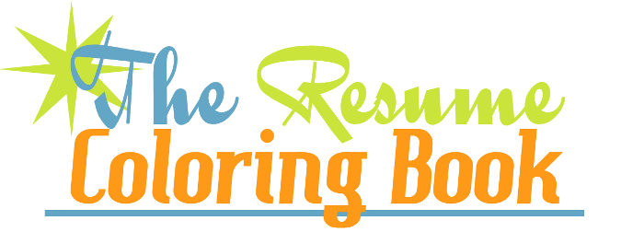
ASCC Resume Coloring Book Summary Review
April, 2015
http://ascc.wsu.edu/career-services/resumes-and-cover-letters/

Total Members: 983 # Completed the Course: 214 # Template downloads: 1146 Percentage completion: 22% (over double the national average for on-line courses)

Recent WSU RCB statistics as of April 10, 2015: See graphs-- WSU students participating in the RCB on-line tool reported in the self-assessment survey regarding their confidence level…
- 28% increase in their ability to write a resume that will get an interview
- 29% increase in the belief that their new resume conveys the skills they possess
- 40% increase in their ability to effectively use keywords
- 36% increase in their ability to design powerful sentences
- 50% increase in their ability to effectively use numbers in their resume

